**Physics 3A/B /155**

**Semester One 2015**

**Question/Answer Booklet**

Student name: _______________________________________

#### Time allowed for this paper

Reading time before commencing work: ten minutes

Working time for paper: two and a half hours

**Materials required/recommended for this paper**

***To be provided by the supervisor***

This Question/Answer Booklet

Formulae and Constants Sheet

***To be provided by the candidate***

Standard items: pens, pencils, eraser, correction fluid, ruler, highlighters

Special items: non-programmable calculators satisfying the conditions set by the Curriculum Council for this course

**Important note to candidates**

No other items may be taken into the examination room. It is your responsibility to ensure that you do not have any unauthorised notes or other items of a non-personal nature in the examination room. If you have any unauthorised material with you, hand it to the supervisor before reading any further.

Student Marks

|  |  |  |  |
| --- | --- | --- | --- |
| **Section** | Percentage of paper | Maximum mark | Student mark |
| Section One:  Short response | 33.5% | 52 |  |
| Section Two:  Problem-solving | 58% | 90 |  |
| Section Three:  Comprehension | 8.5% | 13 |  |
| Student Mark | | | /155 | % |

**Structure of this paper**

|  |  |  |  |  |  |
| --- | --- | --- | --- | --- | --- |
| Section | Number of questions available | Number of questions to be answered | Suggested working time  (minutes) | Marks available | Percentage of exam |
| Section One:  Short response | 13 | 13 | 45 | 45 | 33.5 |
| Section Two:  Problem-solving | 7 | 7 | 85 | 87 | 58 |
| Section Three:  Comprehension | 1 | 1 | 20 | 18 | 8.5 |
|  |  |  |  | 150 | 100 |

**Instructions to candidates**

1. The rules for the conduct of Western Australian external examinations are detailed in the *Year 12 Information Handbook 2015.* Sitting this examination implies that you agree to abide by these rules.

2. Write answers in this Question/Answer Booklet.

3. You must be careful to confine your responses to the specific questions asked and to follow any instructions that are specific to a particular question.

1. Working or reasoning should be clearly shown when calculating or estimating answers. Answers should be given to the appropriate number of significant figures. Answers not given to the appropriate number of significant figures may result in marks being deducted, up to a maximum of 4 marks.

5. Spare pages are included at the end of this booklet. They can be used for planning your responses and/or as additional space if required to continue an answer.

* + Planning: If you use the spare pages for planning, indicate this clearly at the top of the page.
  + Continuing an answer: If you need to use the space to continue an answer, indicate in the original answer space that the answer is continued at the “Back of Booklet”. Clearly label the number of the question(s) that you are continuing at the back of the booklet.

**Section One: 11 Questions for a total of 52 marks.**

**QUESTION ONE** **(5 marks)**

The captain of a cargo ship leaves Fremantle harbour by pointing his ship’s bows NW at a bearing of 3150. The thrust of the engines can propel the ship at 35km/h. Determine the displacement of the ship relative to Fremantle after exactly 24 hours if the ship experiences a constant current, directly south, of 2.5m s-1.

**QUESTION TWO** **(4 marks)**

A rifle is held in a vice so that its barrel is horizontal and 1.6m above a vast, horizontal piece of ground. If a bullet leaves the barrel at 945m s-1, determine:

1. Its flight time (3 marks)
2. The horizontal range of the bullet (1 mark)

**QUESTION THREE** **(6 marks)**

A cyclist and his bicycle have a combined mass of 75.0kg. As part of a road race circuit, there is a bend of radius 38.0m on a horizontal road.

a) At what angle to the horizontal must he lean into this bend to maintain a speed of 58.1km/h? (3 marks)

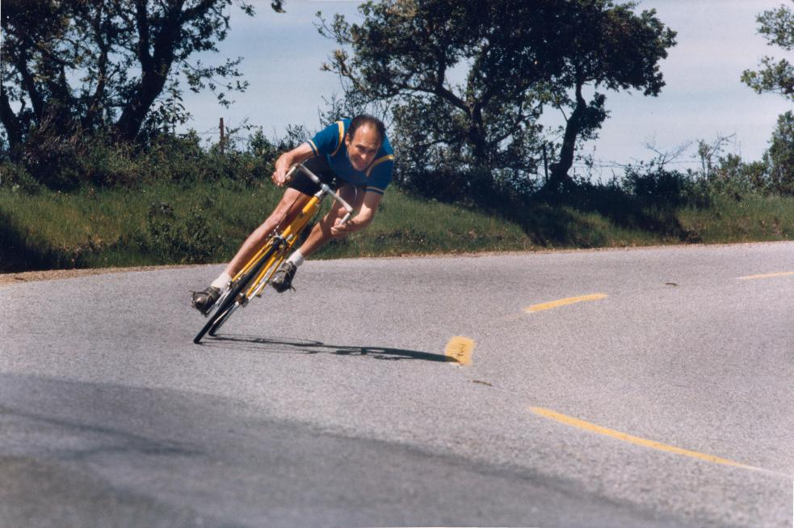

b) Explain, with the use of a free body diagram, why cyclists must lean into bends in order to safely round them. (3 marks)

**QUESTION FOUR** **(4 marks)**

A rollercoaster circuit contains a vertical circular loop, of radius 17m, and each rollercoaster car has a maximum load of 540kg. Assuming the loop is circular, determine the minimum speed that must be maintained in the inside of the loop at the top to prevent the rollercoaster falling off.

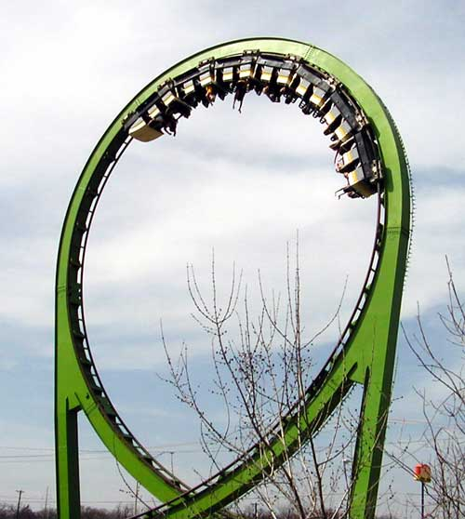

**QUESTION FIVE** **(4 marks)**

Johannes Kepler developed a series of relationships that describe how satellites orbit larger bodies. These are called Kepler’s Laws today. Using your knowledge of Kepler’s Laws, and any relevant data provided on the data sheet, determine the length of a year on Saturn (in Earth days) if Saturn orbits at an average of 1.41 billion kilometres from the sun.

**QUESTION SIX** **(3 marks)**

The photograph below shows a set of screwdrivers.

Explain, with reference to the relevant physical concepts, why the screwdriver on the bottom right would be a lot more effective at loosening a tight screw than the screwdriver on the top right.

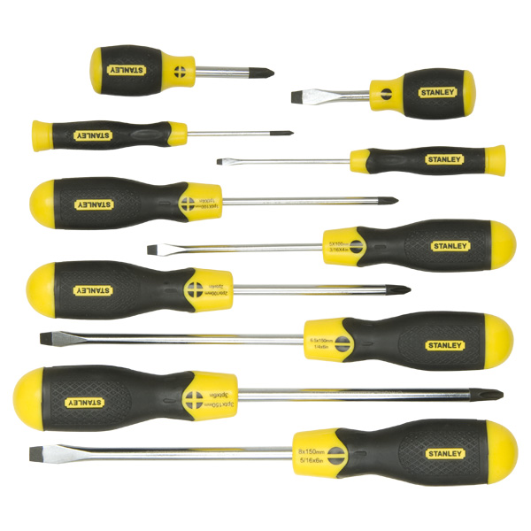

**QUESTION SEVEN** **(5 marks)**

If the mass of the suspended body W is 38kg, determined the magnitude of the tensile forces, T1, T2 and T3 in the three ropes.

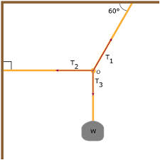

**QUESTION EIGHT** **(4 marks)**

An electro-magnet is fundamentally a piece of iron that has coils of current carrying insulated wire wrapped around it. There are a number of ways in which the magnetic field produced by an electro-magnet can be intensified. List any two and fully explain why they intensify the field.

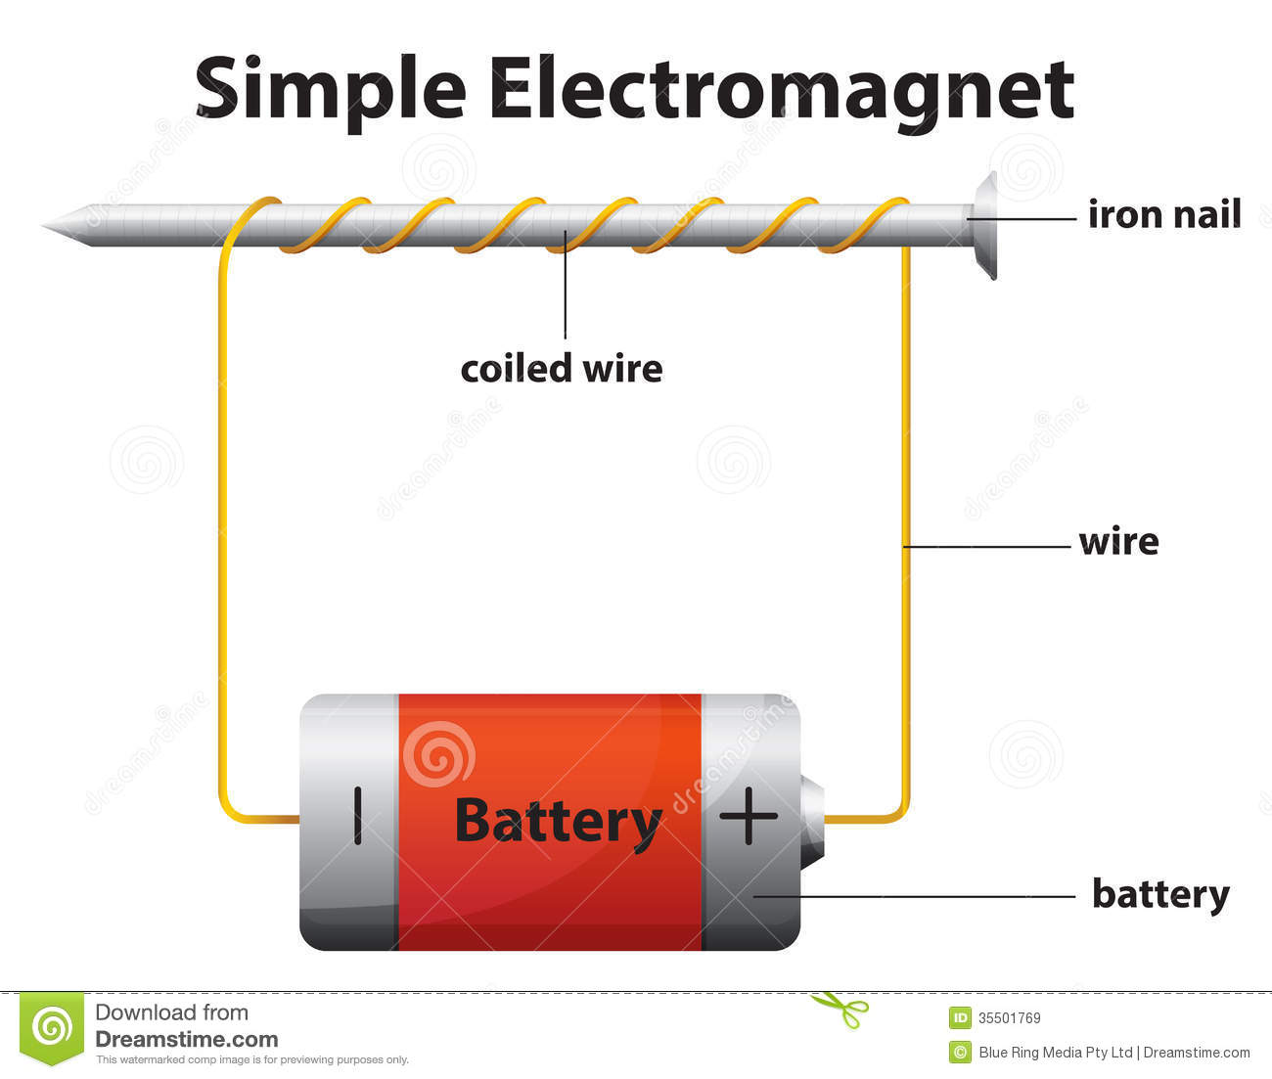

**QUESTION NINE** **(6 marks)**

Neatly sketch magnetic field lines around each of the following (2 marks each):

a)

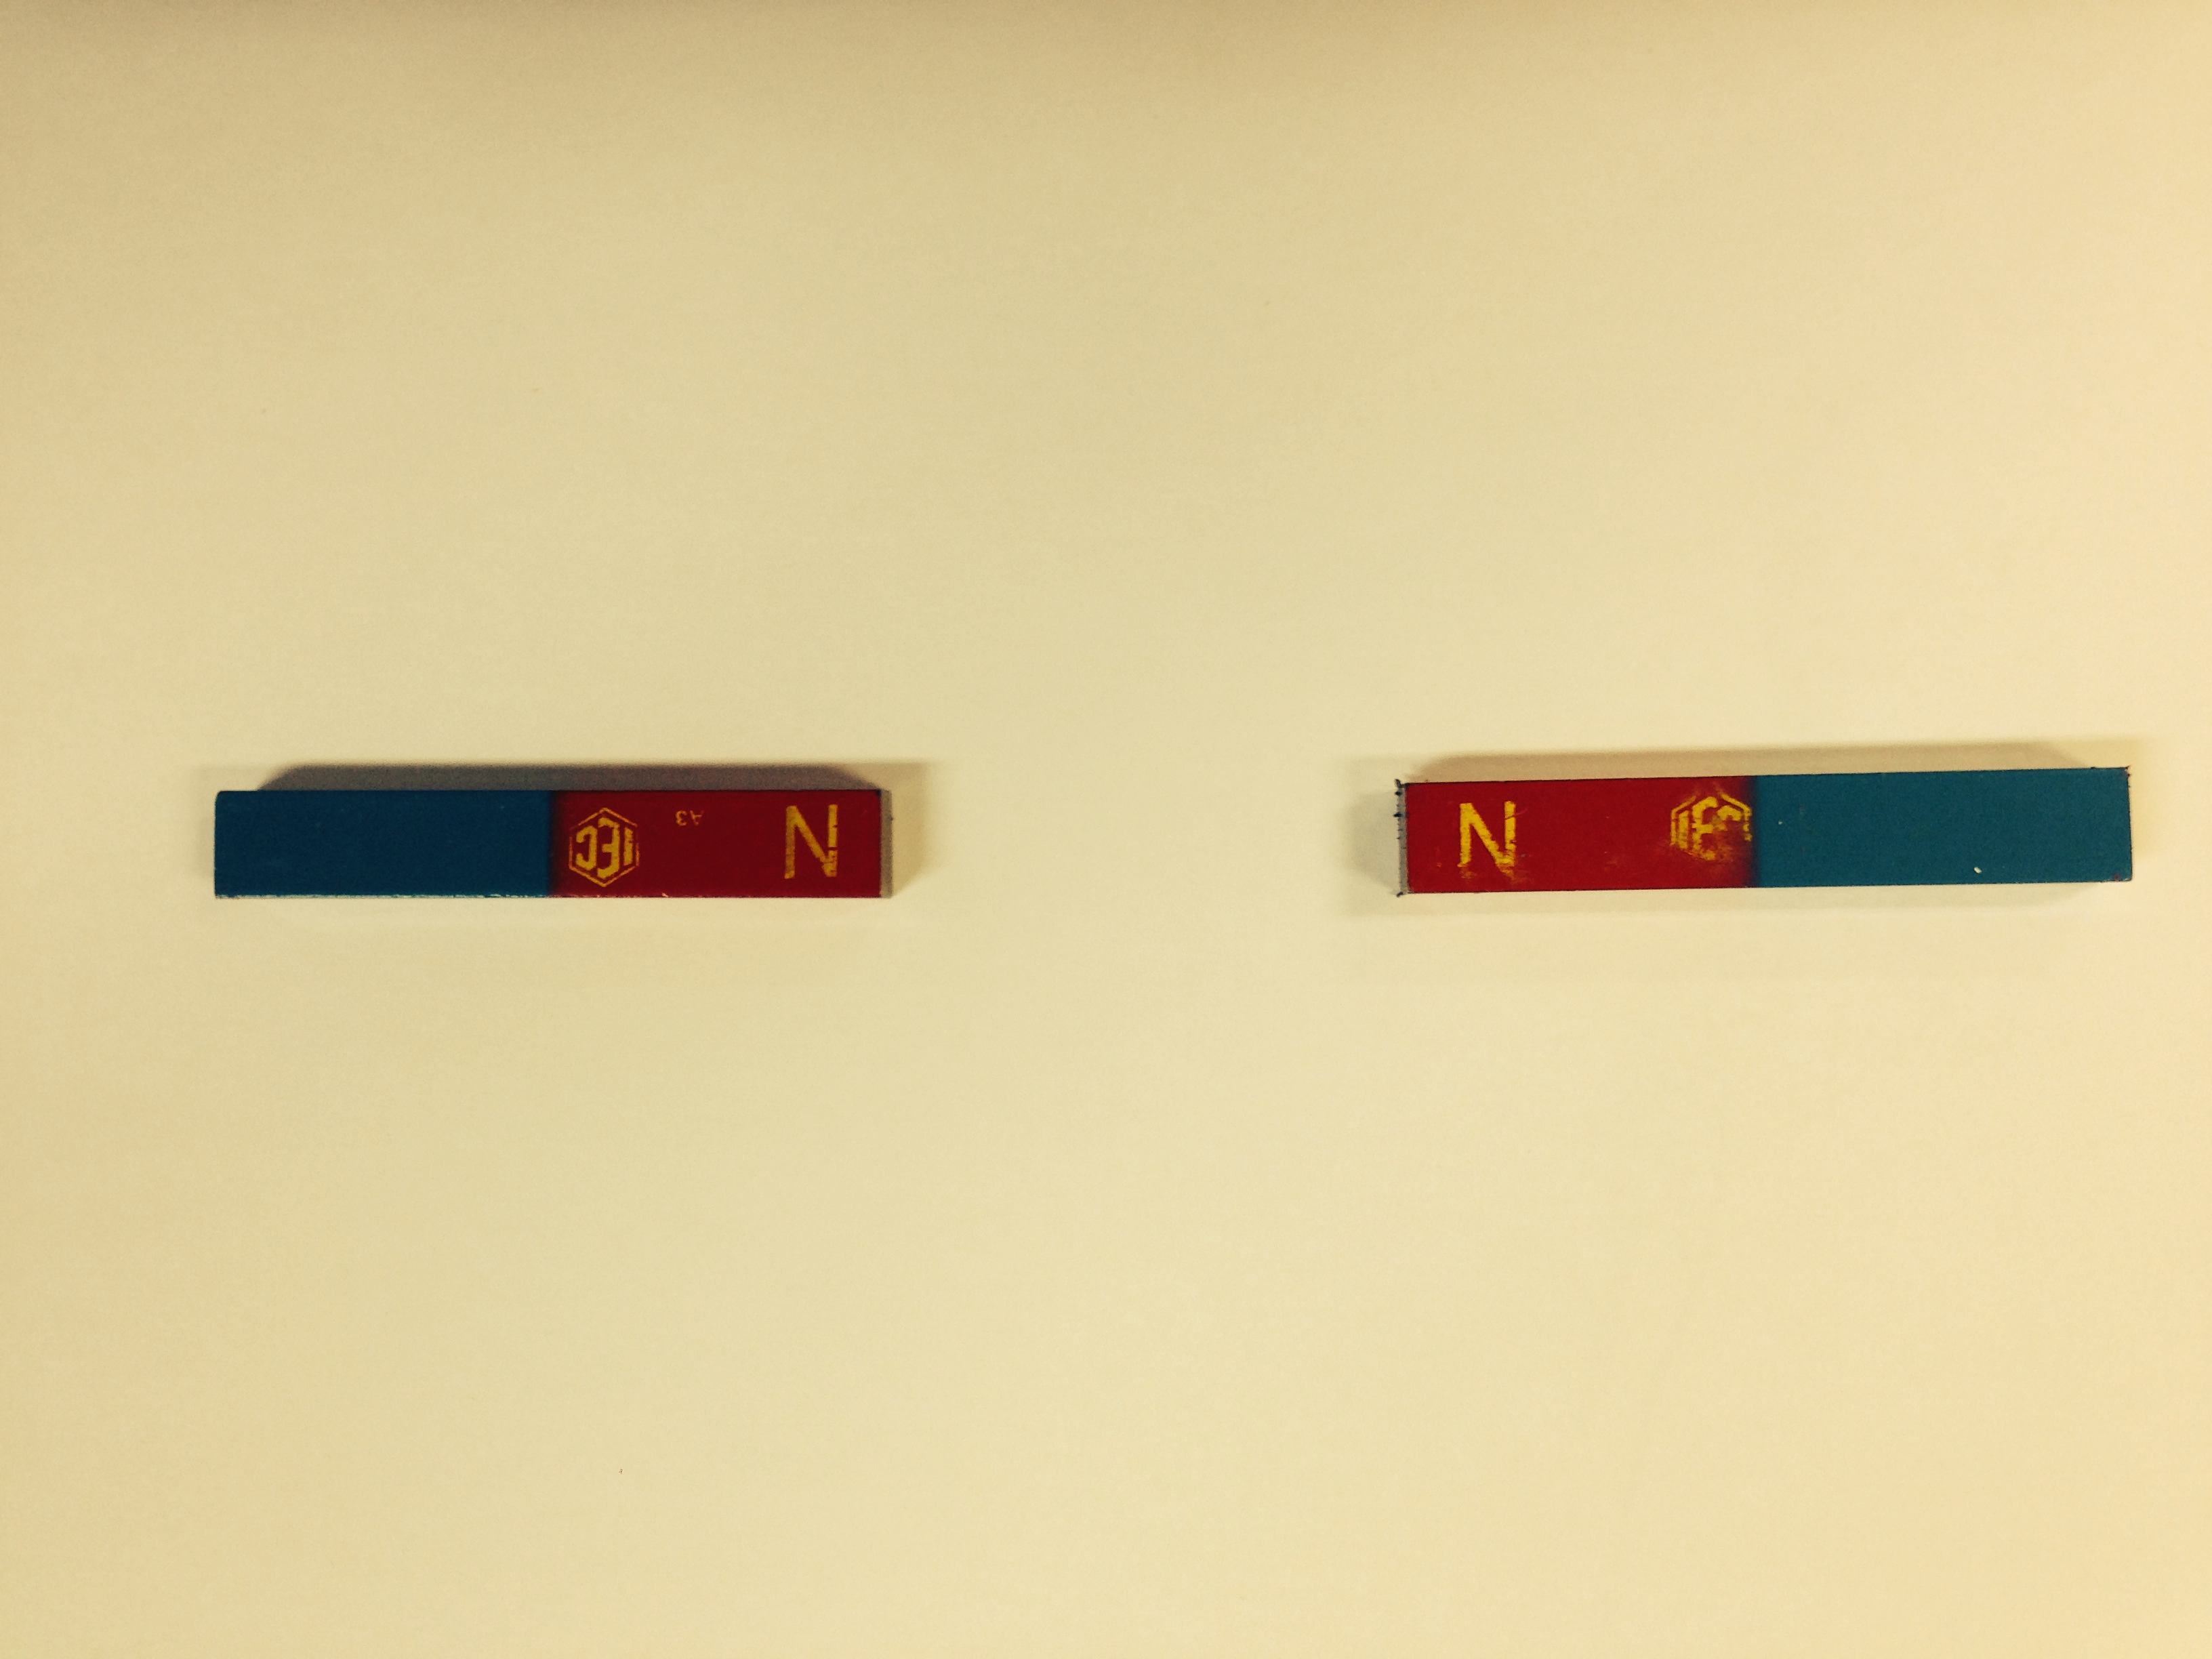

b)

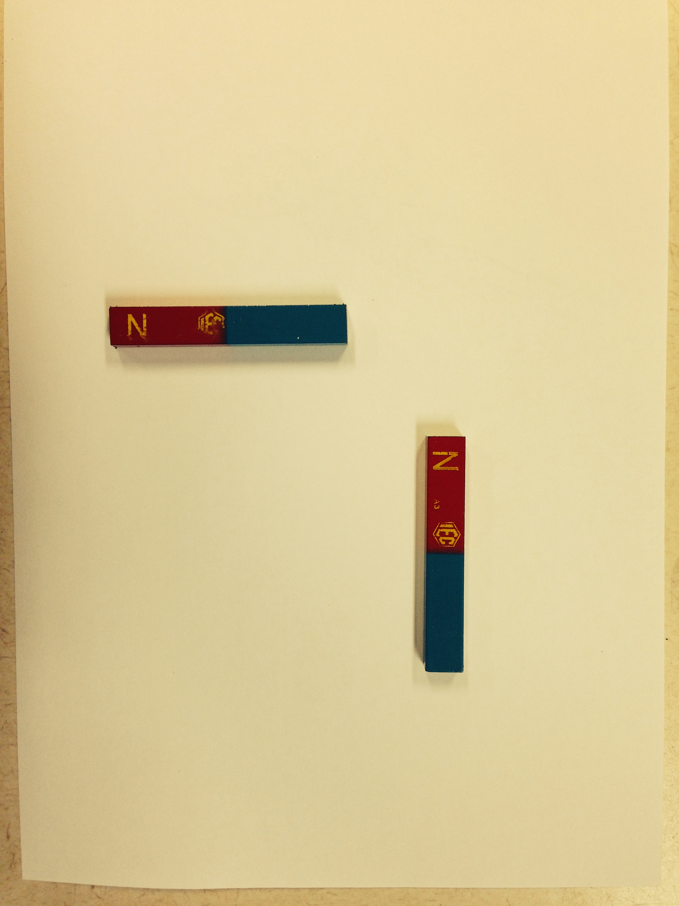

c)

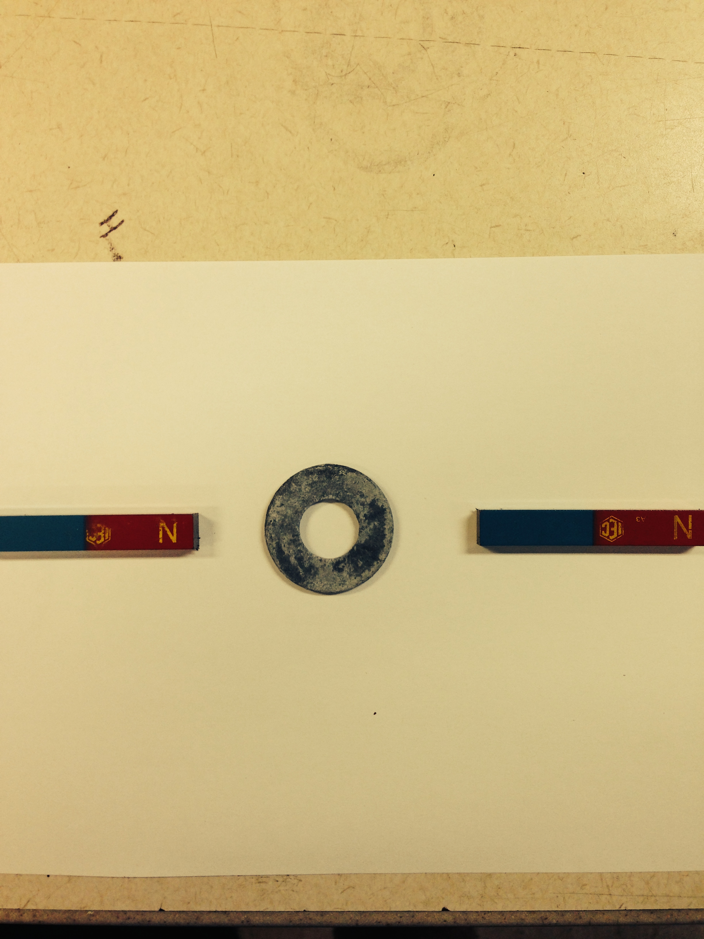

**QUESTION TEN** **(5 marks)**

Lenz’s Law explains the direction of the magnetic field associated with induced currents. The diagram below shows a bar magnet being moved into the opening of a solenoid.

a) Label the north and south poles of the solenoid (1 mark)

b) Show with an arrow the direction of conventional current flow in the horizontal wire that runs either side of the galvanometer (G). (1 mark)

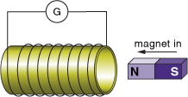

The diagram below shows an electromagnet (A) on the left and a coil of wire wrapped around an iron core (B) on the right. Immediately after the switch “S” is closed, label:

1. the magnetic poles of the electromagnet (1 mark)
2. the magnetic poles of the coil (B) (1 mark)
3. the direction of conventional current flow between a and b (1 mark)

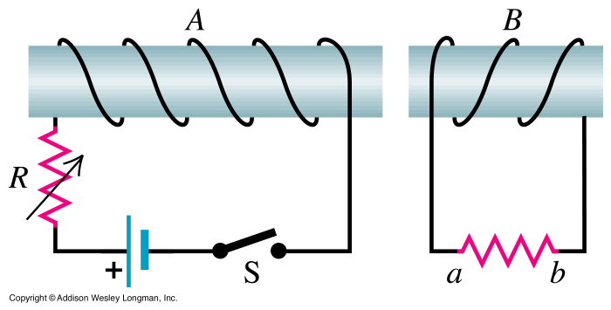

**QUESTION ELEVEN** **(6 marks)**

The transformer in the diagram below is designed to change the incoming 240VRMS voltage in WA to produce a secondary voltage of 12V. There are 1100 windings on the primary coil, and the RMS secondary current is 2.4A (assume 100% efficiency).

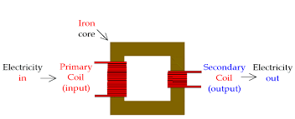

Determine:

a) Whether it is a step up or step down transformer. (1 mark)

b) The peak voltage in the primary coil. (1 mark)

c) The average current in the primary coil. (1 mark)

d) The number of windings in the secondary coil (1 mark)

e) If the number of windings in the secondary coil was halved, explain the effect this would have on the secondary voltage and current. (2 marks)

**Section Two: 6 Questions for a total of 90 marks**

**QUESTION TWELVE (26 marks)**

The diagram below shows a simple AC generator. The dark half of the armature (ie coil) is connected to the dark slip ring and light half is connected to the light slip ring. The coil consists of 45 square loops, each of side length 24cm and is spun clockwise at 6.0 x 102 rpm . The magnetic field intensity is a constant 0.65T throughout the region in which the coil rotates.

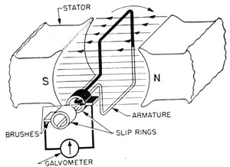

a) Clearly label the direction in which conventional current will flow through the dark coloured wire as it rotates from the position shown for the next quarter of a turn. (1 mark)

b) Determine the magnitude of the average EMF generated for the first quarter of a turn from the position shown. (4 marks)

c) **Explain** the change that would need to be made to the generator to convert its output to DC? (2 marks)

d) There are three sets of axes below.

(i) On the top set, sketch, using appropriate values, how the flux through the coil varies with time for one full rotation starting with the position shown in the diagram. (3 marks)

(ii) On the middle set, sketch, using appropriate values, how the EMF generated varies with time for one full rotation, starting at the position shown in the diagram. (3 marks)

(iii) On the bottom set, sketch, using appropriate values, how the EMF generated would vary if the generator speed was reduced by half to 300rpm. Show the values for one full rotation, starting at the position shown in the diagram. (4 marks)

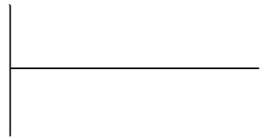





e) The galvanometer in the diagram is replaced with a transformer that is designed so that the secondary coil will produce an average of 240V. Determine:

(i) the turns ratio of the transformer (2 marks)

(ii) the primary and secondary currents if the power output of the generator is 1.2kW (assume 100% efficiency) . (2 marks)

f) Eddy currents are commonly produced by transformers. Explain what they are, how they are formed and how they reduce efficiency in transformers. (3 marks)

g) Transformer manufacturers construct their products to minimise eddy currents. What is their most effective method of minimising eddy currents and how does it work? (2 marks)

**QUESTION THIRTEEN (9 marks)**

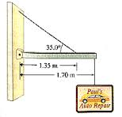

A sign of mass 3.5kg is attached to the end of a 1.70m long uniform beam of mass 12.0kg. The beam is attached to the wall of a mechanic’s workshop by a hinge that allows movement in the vertical plane. The beam is supported by a cable attached to the beam 1.35m from the wall and makes an angle of 35.00 to the beam.

a) Determine the magnitude of tension in the cable. (4 marks)

b) Determine the magnitude and direction of the force of the hinge **on the** beam. (5 marks)

**QUESTION FOURTEEN (18 marks)**

A golfer is about to tee off at the 8th hole at Royal Troon in Scotland. The flag/hole is 156m from the tee, and is situated in the middle of a circular green of radius 8.00m. The golfer decides to use a seven iron, which he knows results in a take off angle of 37.10 (to the horizontal) for the ball. In addition, the tee is located 12.5m vertically higher than the green area. If the ball leaves the club with a velocity of 38.5m s-1, and ignoring air resistance, determine:

a) the horizontal component of velocity (2 marks)

b) the initial vertical component of velocity (2 marks)

c) the maximum height, above the tee area, the ball attains (2 marks)

d) the total flight time of the ball (4 marks)

e) The horizontal range of the ball (2 marks)

f) In the space below, sketch two diagrams: (4 marks)

(i) one showing the trajectory of the ball and the direction of any forces it experiences, ignoring air resistance / drag forces, at the top of its trajectory

(ii) the second showing a more realistic flight path and including drag forces, and the direction of the two forces it experiences at the top of its trajectory

g) If there was a cross wind of 8.00m s-1, blowing at ninety degrees to the fairway, explain the adjustments would the golfer have to make to ensure his ball still landed on the green (no calculations required). (2 marks)

**QUESTION FIFTEEN (16 marks)**

An electric motor is represented by the diagram below. The single coil is constructed from 340 loops of rectangular wire - the lengths of wire perpendicular to the magnetic field are 18cm long and the width is 12cm long. The field strength is a constant 0.72T, and the battery provides a steady 2.4A of current.

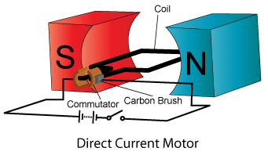

a) What is the function of the commutator and how does it achieve this function? (2 marks)

b) In which direction will the motor spin? Explain. (3 marks)

c) What is the magnitude of the force **on one side** of the motor? (3 marks)

d) What is the maximum **total** torque of this motor? (3 marks)

e) List four ways to increase the motor’s torque. (2 marks)

f) This motor is to be used in a remote controlled, toy racing car, where it will be attached to the rear wheels, which have a diameter of 5.0cm. If the motor will spin at 360rpm, with what speed should the car travel?

(3 marks)

**QUESTION SIXTEEN (11 marks)**

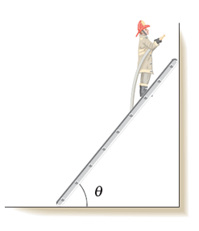Pedro the fireman has a mass of 92kg and is standing ¾ of the way along a uniform ladder of length 6.4 metres and mass 14kg. The angle between the ground and the ladder, , is 520, and the ladder rests against a smooth (ie frictionless) wall. Determine:

a) the magnitude of the reaction force of the wall on the ladder. (4 marks)

b) the magnitude and direction of the force of the ground on the bottom of the ladder (4 marks)

c) as the fireman climbs down the ladder, does the force the ground must provide to support the ladder increase or decrease? Explain. (3 marks)

**QUESTION SEVENTEEN (10 marks)**

The planet Jupiter has a mass of 1.90 x 1027 kg, a radius of 71 500km and many moons. The moon closest to Jupiter’s surface, Metis, has a mass of 9.56 x 1016 kg and a mean orbital radius (around Jupiter) of 1.28 x 105 km. Metis has an average planetary radius of 21.5km.

a) Calculate the gravitational force of attraction between Jupiter and Metis (3 marks)

b) The orbit of Metis is circular. Use your answer to (a) to determine the speed with which Metis orbits Jupiter. (3 marks)

c) Calculate the magnitude and direction of the net gravitational force acting on a 1.00kg mass resting on the surface of Metis that faces Jupiter. (4 marks)

**SECTION THREE - One question worth 13 marks.**

**QUESTION EIGHTEEN (13 marks)**













END OF EXAM